1. Grade Checker

Take a score as input and print the grade based on the following:

90+ : "A"

80-89 : "B"

70-79 : "C"

60-69 : "D"

Below 60 : "F"

here we used a basic if else statement to carry out marks and all.

* Python Code and Explanation Mention Below:

Marks = int(input("Enter Your Marks \n"))

# Takes marks as input from the user.

# int() converts the input into an integer.

if Marks >= 90:

grade = "A"

# If marks are 90 or above, grade is set to A.

if Marks >= 80:

grade = "B"

# If marks are 80 - 89, grade is set to B.

if Marks >= 70:

grade = "c"

# If marks are 70 - 79, grade is set to c.

if Marks >= 60:

grade = "D"

# If marks are 60 - 69, grade is set to D.

else:

grade = "F"

# If marks are below 60, grade becomes F.

print ("Your Grade Is " + grade)

# Prints the final grade.

* Screen Shot Mention Below.

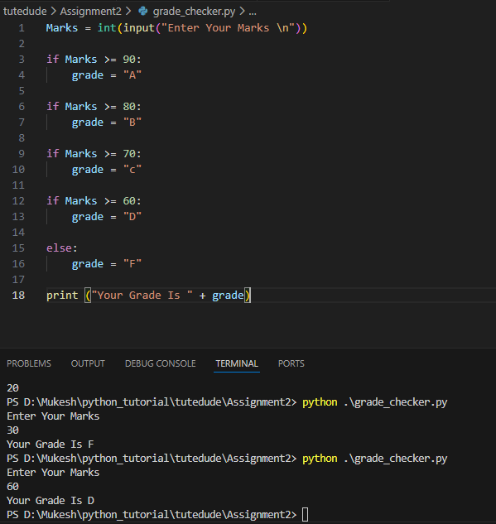

2 Student Grades

Create a dictionary where the keys are student names and the values are their grades. Allow the user to:

Add a new student and grade.

Update an existing student’s grade.

Print all student grades.

Used dictionary and basic operations. Using if else:

* Python Code and Explanation Mention Below:

# Dictionary to store student grades

students = {}

# Add a new student

name = input("Enter student name: ")

grade = input("Enter grade: ")

students[name] = grade

# Update an existing student

update_name = input("Enter student name to update grade: ")

if update_name in students:

new_grade = input("Enter new grade: ")

students[update_name] = new_grade

else:

print("Student not found")

# Print all student grades

print("\nStudent Grades:")

print(students)

* Screen Shot Mention Below.

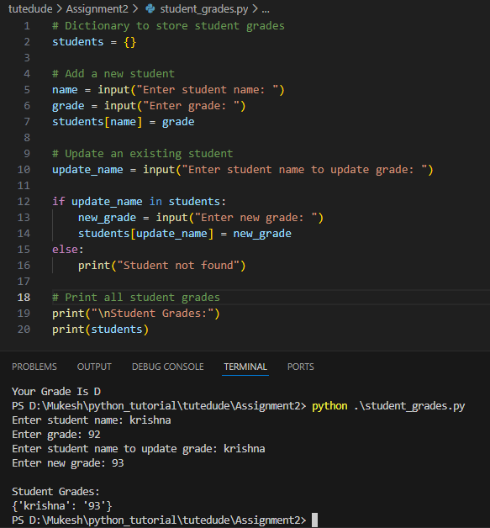

3.Write to a File

Write a program to create a text file and write some content to it.

Using file functions like write and open.

* Python code and explanation mention below.

# Open a file in write mode

file = open("sample.txt", "w")

# Write content to the file

file.write("Hello, This is a new file \n")

file.write("Python file handling")

# Close the file

file.close()

print("Content written to file is success.")

* Screen Shot mention below.

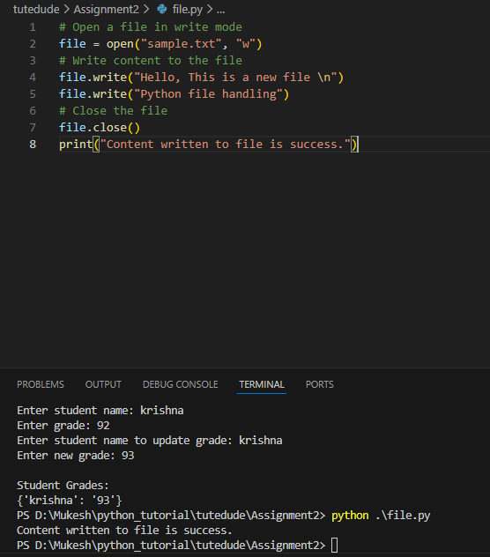

4. Read from a File

We used open in read mode and file.read to read and print to display.

* Python code and explanation mention below.

# Open the file in read mode

file1=open("sample.txt","r")

#read the entire file

sample=file1.read()

#print the data

print(sample)

#close the file

file1.close

* Scree shot mention below.

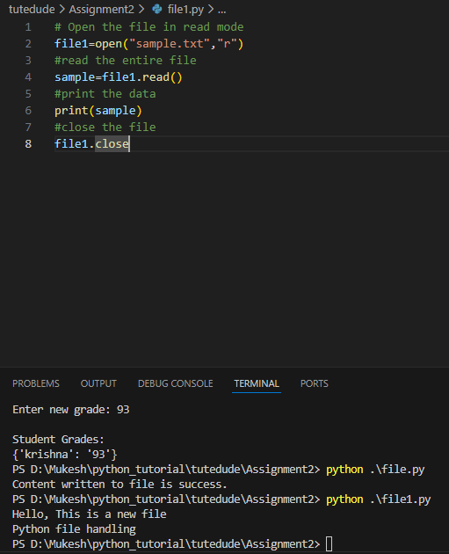

**Submission Guidelines -:** Attach Screenshots or command along with explanation and submit in doc(google doc or microsoft doc) format or share github link